

Subject: Fundamental of AI and ML
Project Title: Ramayan Knowledge Base Using Prolog
Submitted by:
Name: Vanshika Verma
Registration number: 25BCY10171
Branch: Computer Science (Cyber security and digital forensic)
Submitted to: Dr. Satyabrata Nath

Introduction

The Ramayan Knowledge Base is a Prolog-based system designed to model the epic Ramayana in a structured, logical way. The epic contains numerous characters, complex family relationships, events, battles, alliances, and kingdoms. Manually tracing these relationships and events can be overwhelming. This project demonstrates how knowledge representation and rule-based reasoning in Prolog can help organize and query this complex information efficiently.
By representing facts and defining rules, the system allows users to explore relationships, track ancestry, examine alliances and enmities, and analyze battle outcomes. The project serves as an educational example of applying artificial intelligence concepts like expert systems and logic programming to literature.

Problem Statement

The Ramayana features multiple characters with intertwined relationships, kingships, battles, and events. Understanding who is related to whom, who allies or fights against whom, and what events occurred in what sequence is challenging. This project addresses the problem by:
- Representing characters, families, and events in a Prolog knowledge base
- Using rules to derive complex relationships like ancestor, sibling, and allies
- Allowing automatic querying instead of manual tracking
- Providing an interactive platform to explore the epic using logical inference

Functional Requirements

- Maintain male and female characters with their attributes
- Represent family relationships: father, mother, parent, sibling, ancestor
- Encode marriages and symmetric alliances
- Represent major events: exile, abduction, rescue, and battles
- Store battles, killings, weapons used, and defections
- Allow queries for parents, siblings, ancestors, allies, enemies, and event participation
- Support logical inference through rules

Non-Functional Requirements

- Platform-independent; works on SWI-Prolog or online SWISH
- Fast query response for interactive use
- Maintainable knowledge base structure
- Extendable for adding more characters or events
- User-friendly query interface

System Architecture

The system consists of four main layers:
- Input Layer: Users enter queries in SWI-Prolog
- Knowledge Base Layer: Stores all facts about characters, events, battles, alliances, and locations
- Inference Engine: Applies rules to answer queries like parent, sibling, ancestor, and alliances
- Output Layer: Displays results to the user in the Prolog console

Design Decisions & Rationale

- Chose Prolog for its native support for logic programming and inference
- Facts store static data, while rules allow derived knowledge
- Grouped facts by type to avoid warnings and improve readability
- Implemented symmetric rules for marriages, alliances, and enmities to reflect real relationships
- Derived rules (ancestor, sibling) reduce repetition and allow complex queries

Implementation Details

- Language: Prolog (SWI-Prolog)
- Facts: male/1, female/1, father/2, mother/2, spouse/2, ally/2, enemy/2, exile/3, abducted/3, rescued/2, killed/2, used_weapon/2
- Rules: parent/2, sibling/2, ancestor/2, married/2, allied_with/2, enemy_of/2
- Queries: Users can check family relationships, battles, allies/enemies, and events. Example queries include:
  - sibling(ram, Who).
  - ancestor(dasharath, Who).
  - killed(ravan, by(Who)).
  - allied_with(ram, Who).

Screenshots / Results
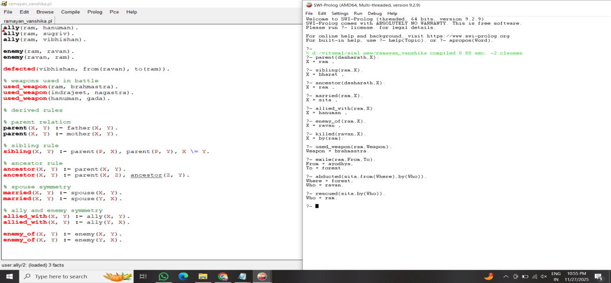

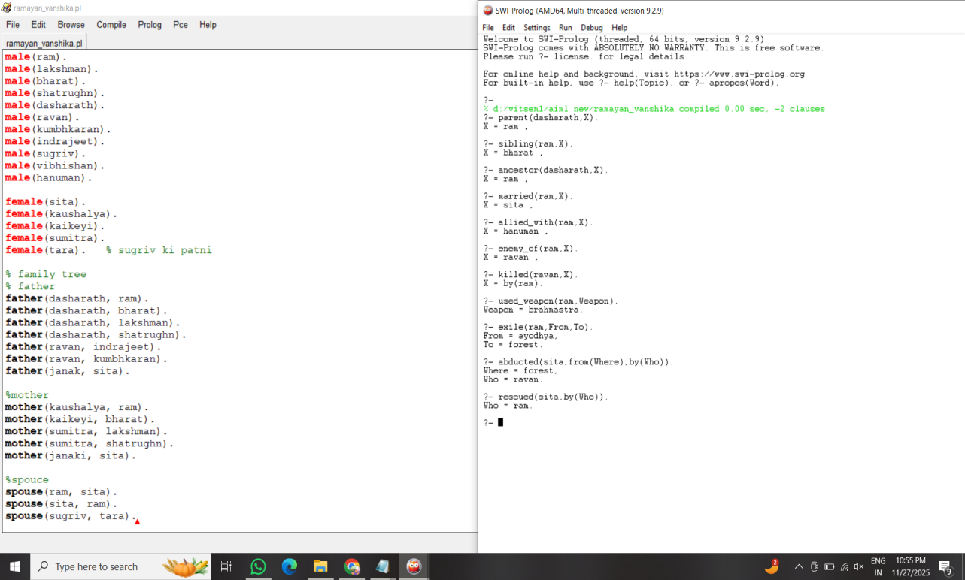

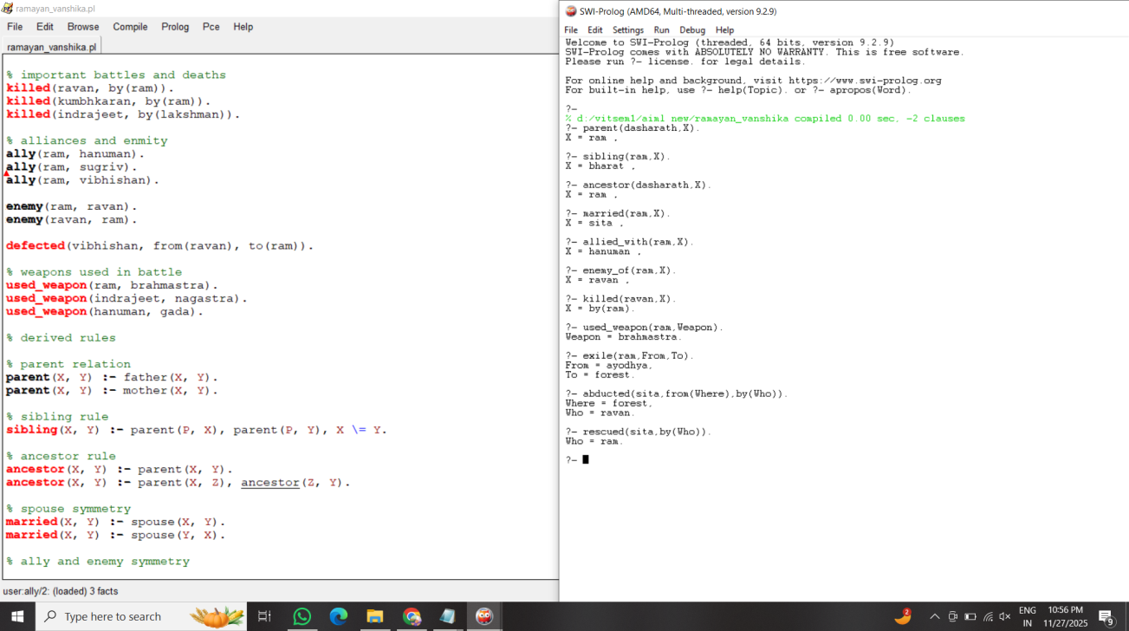
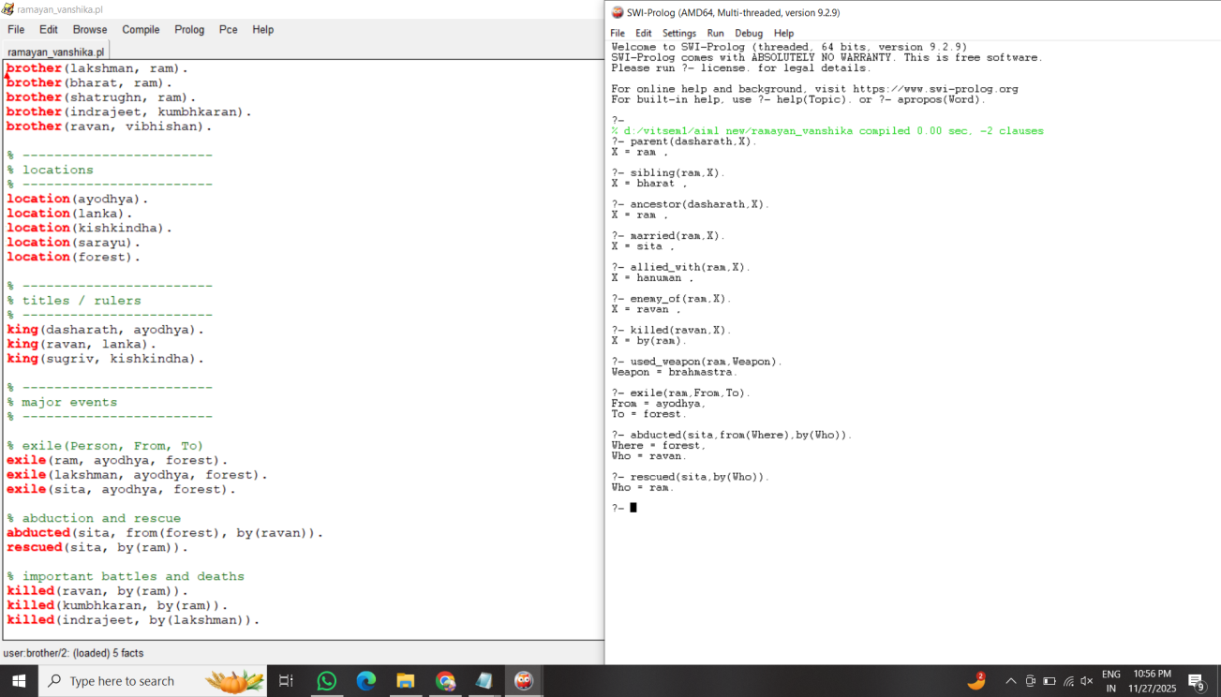

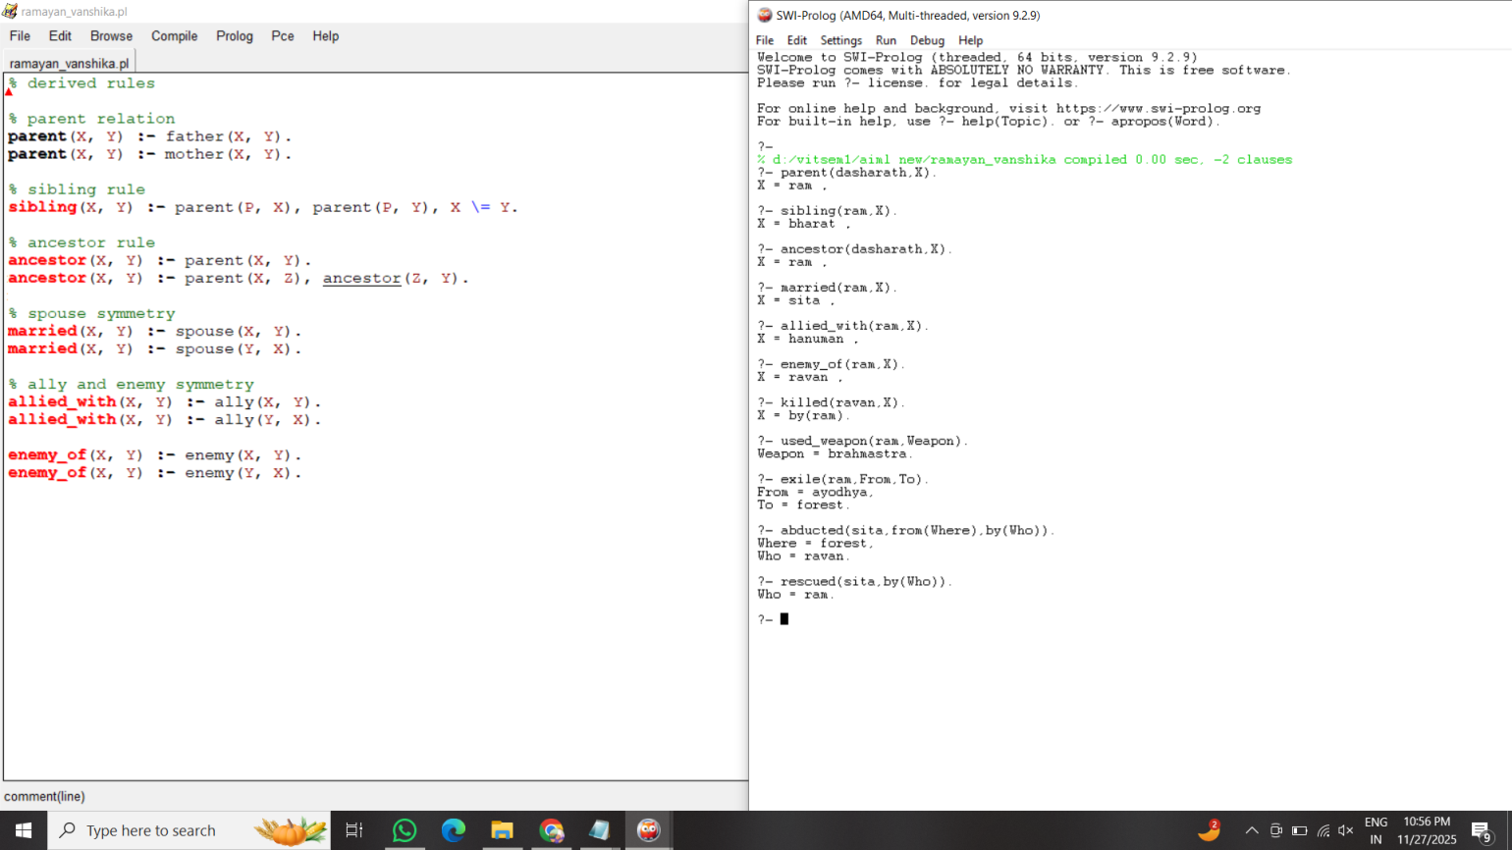

Testing Approach

- Verified all family relationships (parent, sibling, ancestor)
- Checked symmetric rules for marriages, alliances, and enmities
- Tested all major events and battles for correctness
- Compared outputs with Ramayana story to ensure accuracy
- Queries tested multiple scenarios to ensure rules work as intended

Challenges Faced

- Handling discontiguous clause warnings in Prolog
- Implementing symmetric rules for marriages, alliances, and enmities
- Modeling complex events and multi-character interactions logically
- Ensuring derived rules correctly infer relationships without redundancy

Learnings & Key Takeaways

- Learned practical knowledge representation techniques in AI
- Understood rule-based reasoning and logical inference in Prolog
- Gained experience in structuring large knowledge bases
- Learned to debug logical queries and optimize rules
- Understood how AI concepts can be applied to literature

Future Enhancements

- Add graphical interface to visualize family trees and battles
- Include additional characters, events, and epics
- Support natural language queries for easier use
- Integrate with databases for larger knowledge storage
- Generate reports or insights automatically from queries

References

- Youtube
- Swi prolog

